

Quiz Application With Timer and Analysis
Done by:
Faheem Mohammed Shabeer
&
Saad Ahamed Hashim
Batch: 2025-2026
Class: XI-A

ACKNOWLEDGEMENT

I would like to express my sincere gratitude to my Computer Science teacher, Mr. Biswaljit Mishra for their continuous support and guidance throughout the development of this project. Their valuable insights and constructive feedback helped me understand the concepts of GUI programming in Python better.
I am also thankful to our Principal, Dr. Anand Nair for providing us with excellent computer lab facilities and encouraging us to work on practical projects.
I extend my appreciation to my parents and classmates for their constant support and motivation during the completion of this project.

INDEX

 | Topic | Page No.
1. | Overview | 4
2. | Hardware & Software Requirements | 5
3. | Python Code | 6
4. | Python Concepts Used | 15
5. | Project Scope and Improvement | 16
6. | Output | 17
7. | Reference & Bibliography | 20

OVERVIEW

Introduction
The Python Quiz Application with Timer is an interactive desktop application developed using Python's Tkinter library. This project aims to create an engaging and educational quiz system that tests students' knowledge of Python programming concepts covered in Class 11 Computer Science curriculum.
The application features a user-friendly graphical interface with multiple screens including a welcome page, instructions, quiz questions with radio button options, a countdown timer, and a comprehensive results page. The quiz consists of randomly selected multiple-choice questions from a predefined question bank, ensuring variety in each attempt.
This project demonstrates the practical implementation of various Python concepts including GUI development, event handling, data structures, control flow, and modular programming. The application provides immediate feedback on performance with scoring and grading system, making it an effective tool for self-assessment and learning.
Key Features:
- Modern graphical user interface with dark theme
- Timer-based quiz (5 minutes)
- Random question selection
- Automatic score calculation
- Grade-based performance evaluation
- Option to retry the quiz

HARDWARE AND SOFTWARE REQUIREMENTS

Hardware Requirements
Component | Minimum Specification
Processor | Intel Core i3 or equivalent
RAM | 2 GB
Hard Disk | 100 MB free space
Display | 1024 x 768 resolution
Input Devices | Keyboard and Mouse

Software Requirements
Software | Version
Operating System | Windows 7/8/10/11, macOS, or Linux
Python | 3.7 or higher
IDE | IDLE, PyCharm, VS Code, or any Python IDE
GUI Library | Tkinter (built-in with Python)
Additional Modules | random, time, tkinter.ttk, tkinter.messagebox
PYTHON CODE

import tkinter as tk
from tkinter import ttk, messagebox
import random
import time
class QuizApp:
def __init__(self, root):
self.root = root
self.root.title("Python Quiz - Class 11 CS")
self.root.geometry("800x600")
self.root.resizable(False, False)
self.root.configure(bg="#1e1e2e")
# Quiz data - Class 11 CS NCERT based questions
self.questions = [
{
"question": "What is Python?",
"options": ["A snake", "A high-level programming language", "A database", "An operating system"],
"answer": 1
},
{
"question": "Which keyword is used to define a function in Python?",
"options": ["function", "def", "define", "func"],
"answer": 1
},
{
"question": "What is the output of: print(type([]))?",
"options": ["<class 'tuple'>", "<class 'list'>", "<class 'dict'>", "<class 'set'>"],
"answer": 1
},
{
"question": "Which of the following is a mutable data type?",
"options": ["Tuple", "String", "List", "Integer"],
"answer": 2
},
{
"question": "What does the len() function do?",
"options": ["Returns length of object", "Converts to integer", "Creates a list", "None of these"],
"answer": 0
},
{
"question": "Which operator is used for exponentiation in Python?",
"options": ["^", "**", "//", "%"],
"answer": 1
},
{
"question": "What is the correct way to create a dictionary?",
"options": ["d = []", "d = ()", "d = {}", "d = <>"],
"answer": 2
},
{
"question": "Which loop is used when number of iterations is unknown?",
"options": ["for loop", "while loop", "do-while loop", "infinite loop"],
"answer": 1
},
{
"question": "What is the output of: print(10 // 3)?",
"options": ["3.33", "3", "4", "3.0"],
"answer": 1
},
{
"question": "Which keyword is used to handle exceptions in Python?",
"options": ["catch", "try", "except", "Both B and C"],
"answer": 3
},
{
"question": "What is the correct syntax for a single line comment?",
"options": ["// comment", "# comment", "/* comment */", "-- comment"],
"answer": 1
},
{
"question": "Which function is used to get input from user?",
"options": ["input()", "get()", "read()", "scanf()"],
"answer": 0
},
{
"question": "What is the index of the first element in a Python list?",
"options": ["1", "0", "-1", "Depends on list"],
"answer": 1
},
{
"question": "Which method is used to add an element at the end of a list?",
"options": ["add()", "append()", "insert()", "push()"],
"answer": 1
},
{
"question": "What is the output of: print('Hello'[1])?",
"options": ["H", "e", "l", "Error"],
"answer": 1
}
]

# Shuffle questions for randomness
random.shuffle(self.questions)

# Select 10 questions
self.questions = self.questions[:10]

# Quiz state
self.current_question = 0
self.score = 0
self.selected_answer = tk.IntVar()
self.time_left = 300 # 5 minutes (300 seconds)
self.timer_running = False

# Show welcome screen
self.show_welcome_screen()

def show_welcome_screen(self):
self.clear_screen()

frame = tk.Frame(self.root, bg="#1e1e2e")
frame.place(relx=0.5, rely=0.5, anchor="center")

title = tk.Label(frame, text="🐍 Python Quiz", font=("Arial", 36, "bold"),
bg="#1e1e2e", fg="#89dceb")
title.pack(pady=20)

subtitle = tk.Label(frame, text="Class 11 Computer Science",
font=("Arial", 18), bg="#1e1e2e", fg="#cdd6f4")
subtitle.pack(pady=10)

info = tk.Label(frame, text="📝 10 Questions | ⏱️ 5 Minutes | 🎯 10 Points",
font=("Arial", 14), bg="#1e1e2e", fg="#f5e0dc")
info.pack(pady=20)

start_btn = tk.Button(frame, text="Start Quiz", font=("Arial", 16, "bold"),
bg="#89b4fa", fg="#1e1e2e", padx=40, pady=15,
cursor="hand2", command=self.show_instructions)
start_btn.pack(pady=20)

def show_instructions(self):
self.clear_screen()

frame = tk.Frame(self.root, bg="#1e1e2e")
frame.place(relx=0.5, rely=0.5, anchor="center")

title = tk.Label(frame, text="📋 Instructions", font=("Arial", 28, "bold"),
bg="#1e1e2e", fg="#f9e2af")
title.pack(pady=20)

instructions = [
"• Answer all 10 multiple choice questions",
"• Each correct answer gives you 1 point",
"• You have 5 minutes to complete the quiz",
"• Select one option and click Next",
"• You cannot go back to previous questions",
"• Timer starts when you begin the quiz"
]

for inst in instructions:
label = tk.Label(frame, text=inst, font=("Arial", 13),
bg="#1e1e2e", fg="#cdd6f4", anchor="w")
label.pack(pady=5, padx=20)

begin_btn = tk.Button(frame, text="Begin Quiz", font=("Arial", 16, "bold"),
bg="#a6e3a1", fg="#1e1e2e", padx=40, pady=15,
cursor="hand2", command=self.start_quiz)
begin_btn.pack(pady=30)

def start_quiz(self):
self.timer_running = True
self.show_question()
self.update_timer()

def show_question(self):
self.clear_screen()
self.selected_answer.set(-1)

# Header with timer
header = tk.Frame(self.root, bg="#313244", height=80)
header.pack(fill="x")

q_num = tk.Label(header, text=f"Question {self.current_question + 1}/10",
font=("Arial", 16, "bold"), bg="#313244", fg="#cdd6f4")
q_num.pack(side="left", padx=30, pady=20)

self.timer_label = tk.Label(header, text="⏱️ 05:00",
font=("Arial", 18, "bold"),
bg="#313244", fg="#f38ba8")
self.timer_label.pack(side="right", padx=30, pady=20)

# Progress bar
progress = ttk.Progressbar(self.root, length=800, mode='determinate',
value=(self.current_question / 10) * 100)
progress.pack()

# Question area
q_frame = tk.Frame(self.root, bg="#1e1e2e")
q_frame.pack(pady=40, padx=40, fill="both", expand=True)

question_text = self.questions[self.current_question]["question"]
q_label = tk.Label(q_frame, text=question_text,
font=("Arial", 18, "bold"), bg="#1e1e2e",
fg="#cdd6f4", wraplength=700, justify="left")
q_label.pack(pady=30)

# Options
options = self.questions[self.current_question]["options"]

for i, option in enumerate(options):
rb = tk.Radiobutton(q_frame, text=option, variable=self.selected_answer,
value=i, font=("Arial", 14), bg="#1e1e2e",
fg="#cdd6f4", selectcolor="#45475a",
activebackground="#1e1e2e", activeforeground="#89dceb",
cursor="hand2", padx=20, pady=10)
rb.pack(anchor="w", pady=8, padx=40)

# Next button
next_btn = tk.Button(self.root, text="Next →", font=("Arial", 14, "bold"),
bg="#89b4fa", fg="#1e1e2e", padx=30, pady=10,
cursor="hand2", command=self.next_question)
next_btn.pack(pady=20)

def next_question(self):
if self.selected_answer.get() == -1:
messagebox.showwarning("Warning", "Please select an answer!")
return

# Check answer
correct_answer = self.questions[self.current_question]["answer"]
if self.selected_answer.get() == correct_answer:
self.score += 1

self.current_question += 1

if self.current_question < len(self.questions):
self.show_question()
else:
self.timer_running = False
self.show_results()

def update_timer(self):
if self.timer_running and self.time_left > 0:
self.time_left -= 1
mins = self.time_left // 60
secs = self.time_left % 60
self.timer_label.config(text=f"⏱️ {mins:02d}:{secs:02d}")
self.root.after(1000, self.update_timer)
elif self.time_left == 0:
self.timer_running = False
messagebox.showinfo("Time's Up!", "Time has expired!")
self.show_results()

def show_results(self):
self.clear_screen()

frame = tk.Frame(self.root, bg="#1e1e2e")
frame.place(relx=0.5, rely=0.5, anchor="center")

title = tk.Label(frame, text="🎉 Quiz Complete!", font=("Arial", 32, "bold"),
bg="#1e1e2e", fg="#a6e3a1")
title.pack(pady=20)

percentage = (self.score / len(self.questions)) * 100

score_text = tk.Label(frame, text=f"Your Score: {self.score}/{len(self.questions)}",
font=("Arial", 24, "bold"), bg="#1e1e2e", fg="#89dceb")
score_text.pack(pady=15)

percent_text = tk.Label(frame, text=f"Percentage: {percentage:.1f}%",
font=("Arial", 20), bg="#1e1e2e", fg="#cdd6f4")
percent_text.pack(pady=10)

# Grade
if percentage >= 90:
grade = "A+ Outstanding! 🌟"
color = "#a6e3a1"
elif percentage >= 75:
grade = "A Great Job! 👏"
color = "#89dceb"
elif percentage >= 60:
grade = "B Good Work! 👍"
color = "#f9e2af"
elif percentage >= 40:
grade = "C Keep Practicing! 📚"
color = "#fab387"
else:
grade = "D Need Improvement! 💪"
color = "#f38ba8"

grade_label = tk.Label(frame, text=grade, font=("Arial", 18, "bold"),
bg="#1e1e2e", fg=color)
grade_label.pack(pady=20)

# Buttons
btn_frame = tk.Frame(frame, bg="#1e1e2e")
btn_frame.pack(pady=20)

retry_btn = tk.Button(btn_frame, text="Retry Quiz", font=("Arial", 14, "bold"),
bg="#89b4fa", fg="#1e1e2e", padx=20, pady=10,
cursor="hand2", command=self.retry_quiz)
retry_btn.pack(side="left", padx=10)

exit_btn = tk.Button(btn_frame, text="Exit", font=("Arial", 14, "bold"),
bg="#f38ba8", fg="#1e1e2e", padx=20, pady=10,
cursor="hand2", command=self.root.quit)
exit_btn.pack(side="left", padx=10)

def retry_quiz(self):
self.current_question = 0
self.score = 0
self.time_left = 300
random.shuffle(self.questions)
self.show_welcome_screen()

def clear_screen(self):
for widget in self.root.winfo_children():
widget.destroy()

if __name__ == "__main__":
root = tk.Tk()
app = QuizApp(root)
root.mainloop(

PYTHON CONCEPTS USED

Object-Oriented Programming (OOP): The application uses the QuizApp class demonstrating encapsulation and modularity. The __init__ constructor initializes attributes, while methods like show_welcome_screen(), show_question(), and next_question() organize functionality.
GUI Programming with Tkinter: Implements various widgets (Label, Button, Radiobutton, Frame, Progressbar) with pack() geometry manager, event handling through command callbacks, and dynamic color schemes.
Data Structures: Uses lists for storing questions/options and dictionaries for each question (with keys: question, options, answer). The self.questions combines both as a list of dictionaries.
Control Flow: Employs if-elif-else statements for grading and answer validation, for loops to iterate through options, and method calls for navigation between screens.
Variables and Data Types: Instance variables (self.score, self.current_question, self.time_left), Tkinter variables (IntVar for tracking input), and standard types (integers, strings, booleans).
Modules and Libraries: tkinter (main GUI), tkinter.ttk (Progressbar), tkinter.messagebox (dialogs), random (question shuffling), and time (timer functionality).
Functions and Methods: Built-in functions like len(), enumerate(), range(), f-strings for formatting, and def keyword for method definitions.
Timer Implementation: Uses after() method for recursive countdown, converts seconds to MM:SS format, and conditionally starts/stops based on quiz state.
PROJECT SCOPE AND IMPROVEMENT

Current Scope
The application successfully implements an interactive GUI-based quiz system with timer functionality, random question selection, automatic scoring with grading system, multiple navigation screens, and input validation.

Future Improvements
Question Bank Enhancement: Expand question pool to 50-100 questions with difficulty levels and comprehensive coverage of Class 11 syllabus chapters.
Database Integration: Implement SQLite database to store questions, user profiles, score history, and track performance across multiple quiz attempts.
Advanced Features: Add hints, answer explanations, negative marking option, pause/resume functionality, and answer review before final submission.
User Experience: Include background music, smooth transitions, multiple theme options (light/dark mode), and keyboard shortcuts for easier navigation.
Analytics: Generate PDF reports, display time-per-question statistics, performance graphs, and score comparison with previous attempts.
OUTPUT

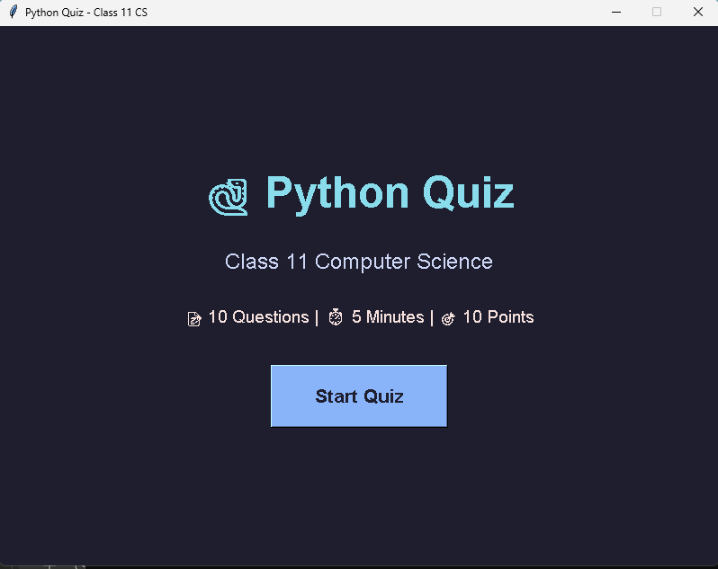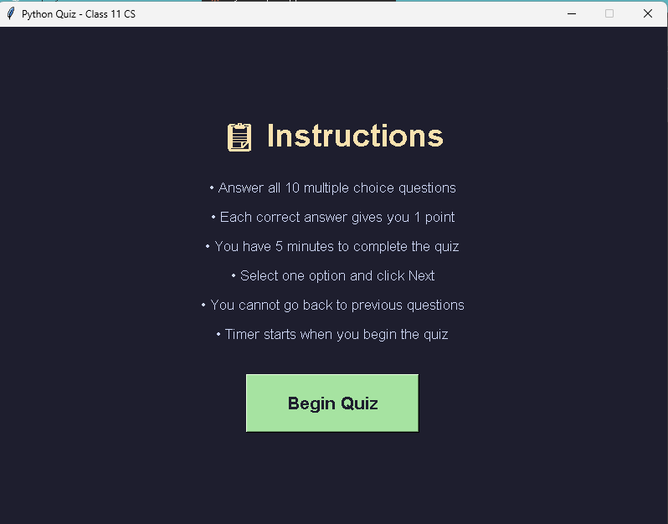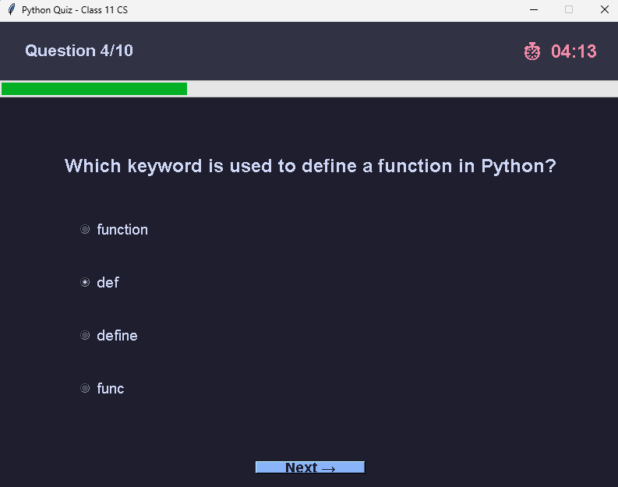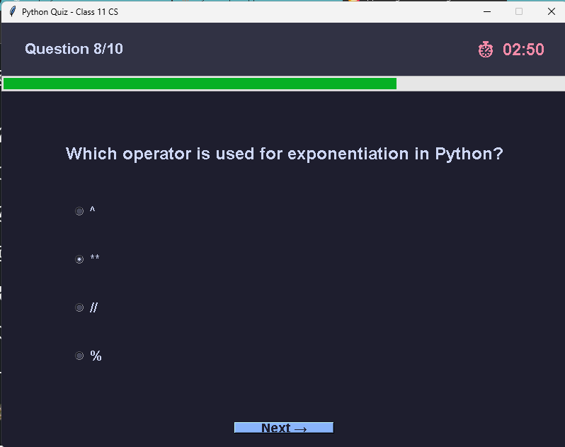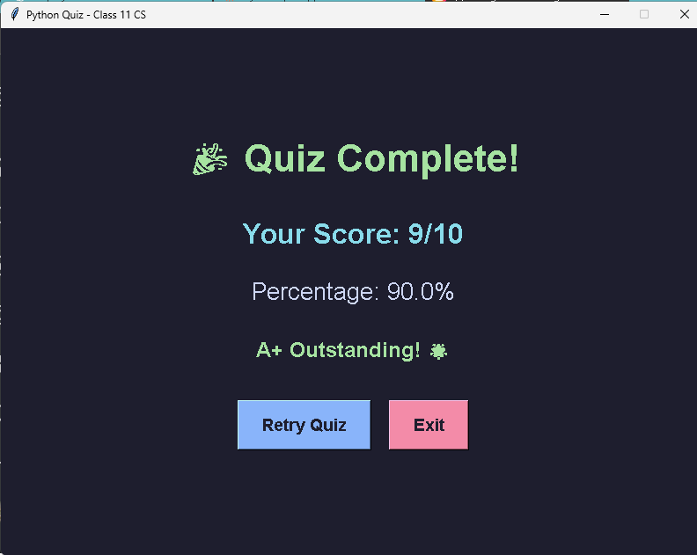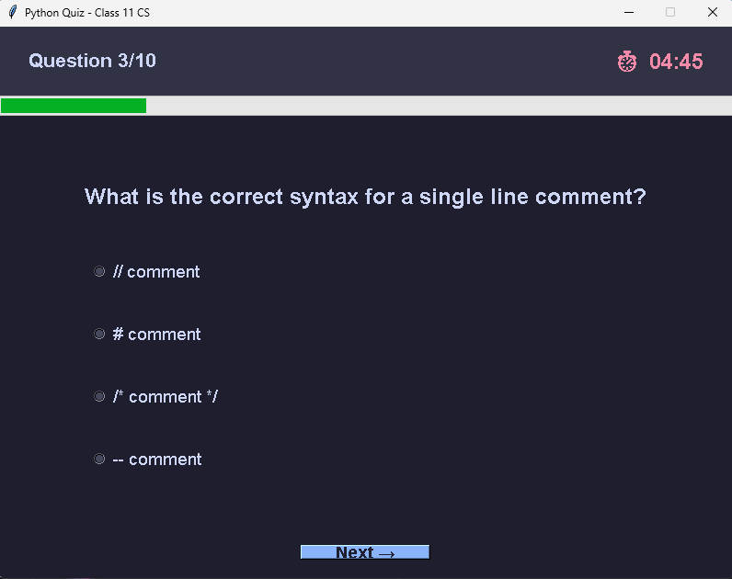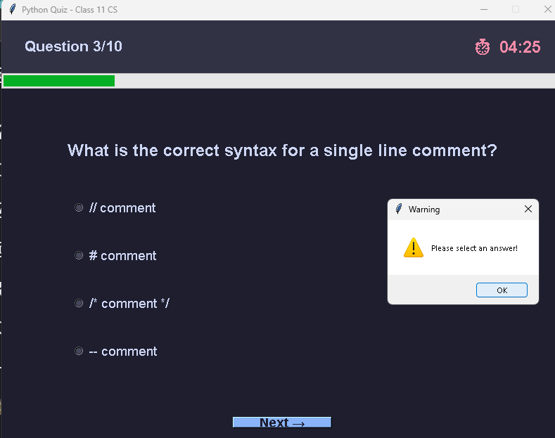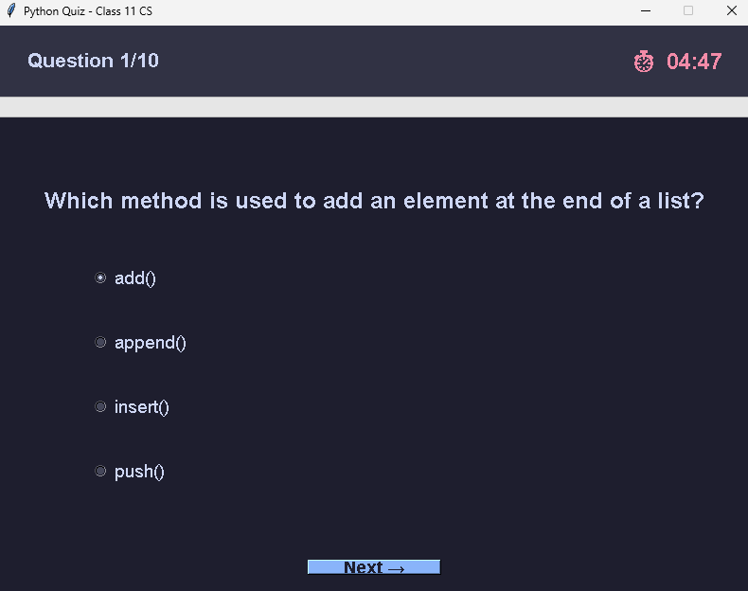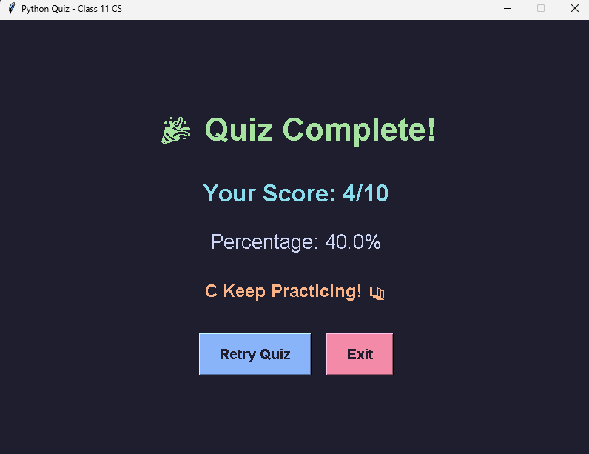

REFERENCE AND BIBLIOGRAPHY

Books
- Computer Science with Python - Class XI by Sumita Arora
- Python Programming: An Introduction to Computer Science by John Zelle
- Learning Python by Mark Lutz

Online Resources
- Official Python Documentation - https://docs.python.org/3/
- Tkinter Documentation - https://docs.python.org/3/library/tkinter.html
- W3Schools Python Tutorial - https://www.w3schools.com/python/
- GeeksforGeeks Python Programming - https://www.geeksforgeeks.org/python-programming-language/
- Real Python Tkinter Tutorial - https://realpython.com/python-gui-tkinter/

Video Tutorials
- Python GUI Programming with Tkinter - YouTube
- Python Projects for Beginners - Coursera
- Computer Science with Python Class 11 - Educational Channels

